Web Development using Wordpress
Unit- 1
What is CMS?
A Content Management System (CMS) can be defined as a tool or software program containing a set of interrelated programs used for creating and managing different digital or online content. Some famous examples of CMS software are
Joomla, Drupal, WordPress, TYPO3, etc. The typical use of CMS is in two areas:
- Enterprise Content Management (ECM) and
- Web Content Management (WCM)
In most cases, CMS can support many users, letting them work in the association. For example, WordPress makes it possible to create many administrative users with different privileges, making the work progress in parallel. Content management systems also comprise text, layout, and design features like the facility to upload multimedia content like photos, videos, audio, maps, or any source code.

Components of Content Management System
A content management system is composed of two major components. These are:
- A content management application (CMA) is a graphical user interface that allows users to create, delete, modify, and publish content without the knowledge of HTML or other programming languages ​​necessary to create web pages.
- A content delivery application (CDA) is responsible for the back-end services. It manages as well as delivers content after being framed in the CMA.
Features of CMS
  - User Management:
It allows management of users' information, such as the roles of different users assigned to work together, creating or deleting users, and changing usernames, passwords, and other related information.

  - Theme System:
Theme System: It allows us to modify the site view and functionality using stylesheets, images, and templates.

  - Extending Plugins:
Different plugins are offered, which give custom functionalities and features to create the CMS site.

  - Search Engine Optimization:
It is embedded with many search engine optimization (SEO) tools that make content SEO more straightforward.
  - Media Management:
It manages media files and folders, making it easy to upload media content.

  - Multilingual:
Translation of the language, as preferred by the user, is possible through CMS.

Advantages of CMS
- Most of the CMS is open source and is available for free.
- Easy and quick uploading of media files can be done.
- Several SEO tools make on-site SEO simpler.
- Easy customization is possible as per the need of the user.
- It can modify CSS files as per the design needed by the user.
- Many templates and plugins are available for free. Customization of plugins is also possible.
- Content editing is also more comfortable as it uses the WYSIWYG editor.

Disadvantages of Content Management System
- CMS software needs a time-to-time update, so the user must look for an updated version.
- Using different plugins can make your website heavy and challenging to run.
- CMS hosting is quite expansive.
- PHP knowledge is required to modify or change the WordPress website.

WEB CONTENT MANAGEMENT SYSTEM

What is a web content management system?
A web content management system is a platform that allows organizations to manage different types of digital information on their website, by creating and managing dynamic content without any knowledge of programming or any mark-up languages.
By implementing dynamically managed web content, businesses can take informed decisions based on insights delivered through the platform.

How does a WCMS work?
A web content management system, also known as WCMS helps in maintaining and controlling the content on a website. The content is stored in a central database and the same is recalled using various programming or markup languages such as XML or. NET. Those who want to access the web page can do so through a web browser. For editing the content, the same can be done through a web browser-based control panel that not only controls the content part, but also the layout and other elements of a web page.
A typical web content management system has two parts:
- A content management application (known as CMA) that helps creators, such as content writers, designers, developers to create the layout of the web page and further modify it to suit their requirements. This does not require any support from the IT department.

- A content delivery application (also known as CDA) that transforms the content created by users at the backend into a visible format for the visitors in the front end. There is a lot of flexibility when it comes to hosting the WCMS application. IT can be either hosted on the own data centre of the organization or on a third-party cloud server.

Why use a WCMS?
Websites are a very important marketing channel for promoting your business. In fact, modern business thrives heavily on websites because it is an important channel for creating inbound interests. A very critical aspect of maintaining a website is the constant update in its content. This can’t be done on a manual basis, which is why the need for a web content management system is inevitable.
If we look at the various digital marketing activities such as emails, social media, print, and other modes of advertisement and promotion, they all route to the website of the company. Hence, it is important for businesses to maintain their website for an effective online presence. Thus, a WCMS serves as a catalyst to propel a company’s web presence through the creation of a variety of content and sharing the same. However, we can also see other use cases of WCMS where companies create e-commerce websites or online stores.
There are numerous tools inside a web content management system that allows organizations to maintain the consistency of their online presence across multiple platforms such as web and mobile. This is done by keeping content and the presentation aspect separate. There are various control options available to help users maintain different versions, automate processes and activities around marketing.

Capabilities & Features
If we look at the capability and features of a typical web content management system, there are three main types such as:
- Flexibility to create personalized content for a website, which can be easily designed, created, and maintained through a WCMS.
- Editors can easily review and approve content before it is published online.
- A fully automated process for publishing the content.

Over and above these main features, there are a few additional features that a WCMs will have. These are:
- Standard and automated templates: It provide users with standard templates that they can use to create content instantly.
- Access: Empowers administrators to control access to the page of the website.
- Scalability: WCMS are scalable systems, thereby making it easy for organizations to implement them across the board.
- Ease-of-use plugins: Allows users to further extend the functionality of the website through the usage of plugins or add-on modules.
- Workflow: This allows users to set up review mechanisms for publishing their content.
- Document Management: Allows users to store multiple versions of documents and maintain a proper archive of the same.

Advantages & Disadvantages of a WCMS
As we all know that technology has its own pros and cons. So does a web content management system. Let us look at some of the key advantages and disadvantages of a WCMS.
Advantages | Disadvantages
Cost-effective: Some of the WCMS platforms available are free or come at a very low cost. | However, when it comes to large-scale implementations, the cost can go on a higher end.
Ease to use: Most of the WCMS tools are user-friendly and people with zero coding experience can also configure the system and use it. | There is a possibility of delays due to latency issues, on large systems. This is due to dependency on the hardware side.
Customizable: The tool comes with easily customizable front ends. | In absence of regular updates and patches, the system can be vulnerable to cyberattacks. Constant monitoring of components such as MySQL and plugins/add-ons.
Admin users can seamlessly manage workflows within the CMS. | Most of the WCMS tools are SEO friendly as there are various tools that users can use for editing to improve the search ranking of the website.

Examples of WCMS Solutions
These are some of the web content management systems that are quite popular in the market.
- Org
- Drupal
- Joomla
- Volusion

Some of them come with a free version with minimum features to be used. However, the paid version has a larger configuration panel with a full suite of features to be used. Each example has its own pros and cons, which the user has to decide after mapping their requirement with the right vendor.

Web Content Management System Types
To classify web content management systems, we can put them into three main buckets

Online Processing
It works on the mechanism of deploying online templates that have an impact on the web page on a real-time basis. As and when a change is made, the update is published instantly on the live web page.

Offline Processing
In offline processing, the content is created in an offline mode, where the users are not connected to the internet. This method allows complete due diligence of the content before it is published to the live server.

Hybrid Processing
Here, users use a combination of online and offline mode, through the usage of tools such as JSP, ASP, or PHP, instead of the traditional HTML.

Traditional CMS vs WCMS
The word CMS and WCMS are quite often used interchangeably. This is primarily due to a lot of similarities between the two. However, there are dis-similarities too between the two.
- A traditional CMS is used by companies to create, manage and modify content, which can be any structured content such as documents, records, video, and audio content.
- However, a WCMS is a solution that is used to create, manage and modify the content of a company’s web page. This includes content that is textual in nature along with audio, images, graphics, and others.
COMPONENT MANAGEMENT SYSTEM
A Component Content Management System (CCMS) is a system that lets you manage content at a component level. A CCMS allows your teams to author, manage and share content in real-time across any website, app, portal, or knowledge base. This system tracks links, versions, and metadata associated with each component.

A typical content management system tracks content in the form of posts, pages, or documents. We linearly write these documents and often apply the formatting while we write. Because we write them as whole documents, the system manages the content as documents.
The primary difference between a typical CMS and a CCMS is the level of content management.
A CMS gives you some control over your documents, but it is not granular enough to achieve the functionality that we previously mentioned. A CCMS provides this granular control because content is created in the form of components.

NOTE:
A typical CMS manages content at a document level.
A CCMS manages content at a component level.

What is a Component?
A component is a chunk of structured content of any length that is independent and self-contained. A component can be a single word, a series of paragraphs, an image, or a video.

Components are different from documents in size, but also in how they are created.
In a CMS, we write documents in a linear, contextual manner. This style is a natural way to communicate. When we write, the ideas bleed together, like the colours in a child’s
watercolour painting.

In a CCMS, we write components in a modular manner. This style is independent and self-contained. The intent is to avoid contextual dependency if possible. Content written in a modular vs linear manner is a crucial distinction because writers can then use these components to build the documents. Using components already written, authors can freely move, rearrange, or remove the parts to construct new documentation from existing components.
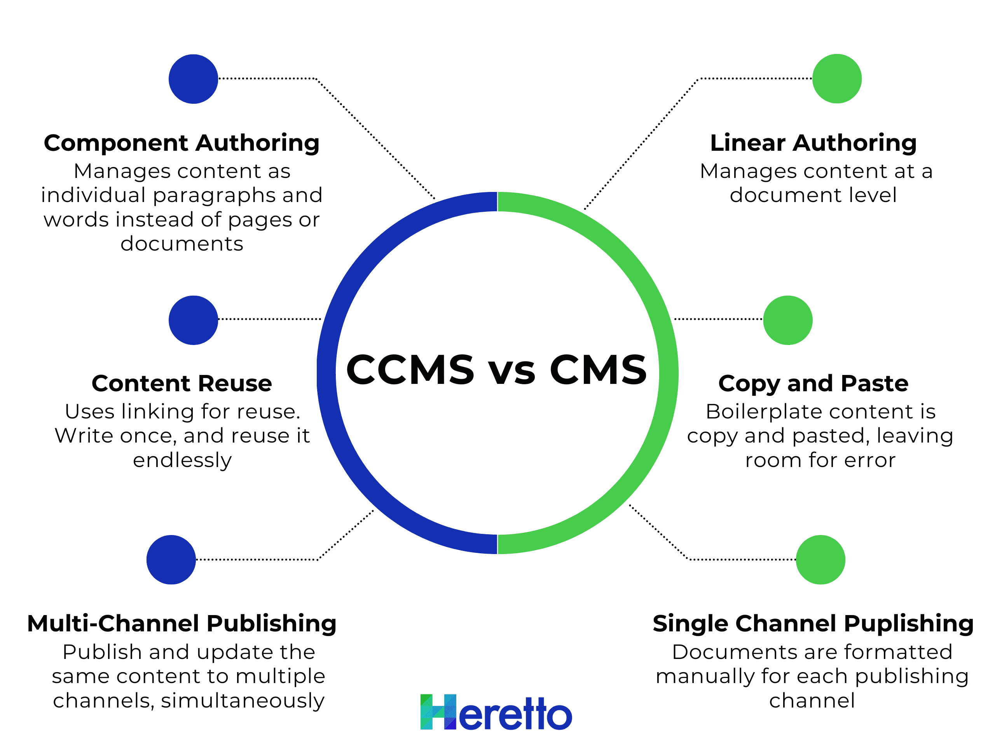

Components are Everywhere
Components aren’t unique to documentation.
Many products have embraced componentization.
Let’s take the example of a car. If your transmission fails, you will probably replace or repair the transmission rather than buy a new car. The vehicle manufacturer understands the importance of componentizing the product both for production speed and cost-effectiveness.
When a car manufacturer builds a new car, they are NOT creating a bespoke piece of art. They are selecting from an assortment of new and existing parts and then assemble those into a vehicle. By assembling from components, the manufacturer increases their production speed and reuses the same components for different models.

The use of components in car manufacturing might all seem rather obvious, but that’s because componentization is old news in car manufacturing.

Reusing content is the same. Instead of creating a totally new document each time, you take pieces you’ve already created and can easily add to them to create a much quicker new document.

Updating Components
One of the best things about a CCMS is that it future-proofs your content.
Since documents are written linearly in a typical CMS, the ideas are intertwined and difficult to isolate. When one idea contains content that requires updating, it’s tricky to update with precision. Linearly written documents are time-consuming and expensive to update, maintain, re-format, republish, and re-translate.

Components are different
Documents composed of components are resilient against the (metaphorical) corrosion of time. Individual components are fast to update since they are short and self-contained, but the speed doesn’t stop at the component level, it extends to your whole content repository.
Instead of re-writing or copying and pasting content, components are reused and linked. If a writer creates a masterful product description, they reuse that component, linking it to every applicable instance where that product description is required.
If you have several similar product you’ll likely create many documents that are extremely similar. If you have two documents that are 90% the same, with only a few small details needing to be changed, content reuse makes it a snap. You can simply change the necessary content without touching the other 90%, all without copying and pasting.
Linked components become even more convenient when it’s time to update your content. When our writer’s masterful product description needs an update, he updates the original component and that update occurs in every instance of reuse.
Since your content is stored in one single place, it becomes a single source of truth. You don’t have to wonder if the document you have is the original or a copy.
Sounds like magic, but it’s just a Component Content Management System at work.
Here’s an example:
Let’s say you create a sell sheet for your newest products. If your prices change a year later, you can simply go into the CCMS and update it. Then, everywhere you’ve published that document will be updated automatically. You don’t have to recreate the document and remember all the places you’ve published it.

How a CCMS Makes Components Possible
Components are powerful but only if managed with the right system. The right system can track specific and relevant metadata about each component. And this is exactly how a CCMS works.
Metadata makes the functionality of a CCMS possible no matter the scale.
This granularity separates a CCMS from other content management systems.
A CCMS tracks the content on a granular, or component, level
- It tracks the location of those components within your system
- It tracks the relationships and associations with other components
- It tracks the use and status of those components— things such as publishing outputs, workflow status, translation status, and audit trails
Granular control of components opens the door to amazing benefits.

More Benefits of Granular Control

Fast Searching
Companies waste a ton of time searching for existing content. The average knowledge worker spends 19% of their day searching for existing knowledge.
A CCMS uses metadata to enable faceted search and reduce the time spent searching.
Users can search for components by:
- Title
- Workflow status
- Author
- Date
- Keyword
- File-type
- Publishing status
The possibilities are endless. You can even create custom metadata fields and tag the components specifically for your internal workflows. This is called structured content.
With a CCMS, your team knows exactly where to look and exactly how to find it.

Single Source System
Your component content management system becomes your single source system. This means that there is one single place where all of your content is stored, and when you reuse components you’re not creating a new one, you’re using the existing one.
This Single Source centralizes your content. This eliminates knowledge gaps and department silos.
A Single Source System also streamlines your content creation process. You can write, edit, manage, and publish, all from one system.
A single source system eliminates questions about:
- Versioning
- Branching
- Authoring status
- Reviewing status
- Publishing status
A single source puts everyone in the same system and on the same team.
You can learn more about a single source here.

Content Reuse
Components are perfect for powerful reuse across your documentation. Since the components are self-contained and modular, you can use them in many locations. This means creating microcontent is a breeze.
A Component Content Management System uses linking for reuse, not copy and paste. This linking means that you write once, and reuse it endlessly.
Read more about the different types of reuse or learn about how reuse improves your document speed by 50%.

Multi-Channel Publishing
Components are excellent for publishing the same content to multiple channels, simultaneously.
Typical CMS’s make publishing difficult and slow. Writers waste time formatting the document manually for each publishing channel. One example, Microsoft word users, can often spend 30-50% of their “writing” time formatting their content.
With a CCMS, the formatting is automatically applied during the publishing process. By automating these time-consuming and mundane tasks, writers focus on creating excellent content and publishing that content in a fraction of the time.

Future-Ready
Unstructured content in a document is difficult to build upon and deploy to modern technology. Many content management systems and their users fall behind due to the inability to freely exchange data with other systems and applications.
Content deployed from a CCMS is more useful than content from unstructured systems because components are more precise than delivering entire documents. When customers or services need nuanced and relevant content, a component delivers.
The real advantage of using a CCMS is getting the right knowledge to the right people, right away. From increasing customer satisfaction and loyalty to cutting down on wasted time and employee frustration – in a lot of ways, your content has never held more power. And a CCMS is just what you need to unleash it.

How Allstate Business Insurance Leveraged Their CCMS to Improve Customer Satisfaction
The power of a CCMS sounds good in practice, but it also works in action.
One of our Heretto customers, Allstate Business Insurance, wanted to find a better way to deliver content.
The problem? Agents were having to read 20-page to 200-page PDFs to find an answer to a customer’s or prospect’s question about a policy. They called Allstate Business Insurance’s own help desk to get questions answered over the phone. This knowledge gap was expensive, and it forced specialists to spend their day answering repetitive questions.
Allstate’s solution was to create a chatbot named ABIE. The chatbot system is connected to their Heretto CCMS. Agents and customers could type their questions, and the chatbot would deliver the exact component of content that answered their questions with precision and accuracy.

What Is Enterprise CMS?
An enterprise CMS is a content management system that’s equipped with the features and capabilities enterprise marketing departments need to engage prospects and ultimately drive revenue.
With the right enterprise CMS, your marketing department can execute a successful enterprise content management (ECM) strategy. ECM is the process of managing and applying content throughout its lifecycle to support employees and furthers business goals. W
Let’s explore more critical reasons why it’s so important to choose the right enterprise CMS for your business.
Enterprise content management (ECM)
sometimes referred to as document management or records management is the process of managing the entire life cycle of an organization’s content, including documents, spreadsheets, contracts and scanned images.
The goal of an ECM solution is to reduce risk and improve productivity, efficiency and customer experience by eliminating paper-based tasks and enhancing process visibility.

What is an ECM solution?
Enterprise content management is an umbrella term for the technology, strategy and method used to capture, manage, access, integrate, measure and store information.
The value of today's ECM solution goes beyond simple scan, store and retrieve solutions to encompass all the platform's capabilities and strengths.
Traditionally, ECM was primarily comprised of transactional content management, a system of record for managing process-related documents. But transactional content management, often associated with business processes that help drive actions and decisions, is just part of ECM and another term under its umbrella.
First-generation enterprise content management solutions no longer fully reflect the way users create, use and interact with information, which is why the term has evolved into content services. A successful content services approach helps you tackle changes in technology and the way we work, and combats information silos by delivering the right information to the right people at the right time.
Benefits of ECM:
- Reduce clutter while increasing data and process visibility and accessibility, ultimately saving time and significantly lowering costs
- Archive information and access it quickly anytime, anywhere
- Eliminate paper-based tasks and make records-keeping more accessible and efficient
- Organize and structure your company’s data to easily cross-reference, providing invaluable context around and transparency into processes

Features of an enterprise content management system
The right platform enables you to build unlimited tailored solutions that integrate and work with your core applications and systems. The features to look out for can be categorized into nine main functions.

Capture
This is the critical starting point of your content management journey. Capture documents — even in structured and unstructured formats — and automatically and intelligently extract, classify and validate information before seamlessly integrating it with core business applications.

Content management
Get a complete view of your processes. Automated content management simplifies access to the files you need so your team can make faster, better-informed decisions.

Business process automation
Streamline critical processes. Automate repeatable tasks, route documents, manage exceptions and extend key processes using configurable workflow tools and built-in rules and actions that are easily customizable without IT support.

Case management
Get full visibility into an entire case from start to end. Staff gets a 360-degree view of all the information they need for effective case management and enhanced customer service.

Customer communications management
Improve customer communications with content management integrations. Create individually personalized content and handle a wide range of communication needs to meet customer expectations.

Collaboration
Share content, collaborate on documents and extend related processes to your users — whether internally or externally — in a secure environment.

Reporting and analytics
Discover, analyze and reimagine reporting and analytics. Gain visibility into your content and processes in real-time with interactive dashboards and audit trails of all activities.

Search
Find the content you need no matter where it resides. Intelligent query tools let you search through repositories, sites, email systems, intranets and more from a single platform.

Records and retention management
Meet regulatory and compliance standards. Configure automated rules and workflows for easily overlooked tasks like approvals, storage, archival and deletion.
.

What does ECM mean and why is it important?
An Enterprise Content Management (ECM) system enables organizations to securely manage content and information throughout its lifecycle. It enables unstructured information — such as Word documents, PDFs, emails and scanned images — to be securely stored and made accessible to authorized users.
From commercial supply chains to contract management, HR processes to government administration, the driving force behind implementing an ECM solution is to do business more efficiently. By eliminating dependence on paper documents and organizing unstructured information according to business needs, organizations can simplify and streamline work.

Top 5 Elements of ECM
Listening to our customers over the years, we’ve found consistent goals for implementing ECM. Customers commonly rely on ECM to:
- Decrease dependence on paper and streamline business processes.
- Drive better customer service and increase productivity.
- Reduce organizational risk.
Leading ECM solutions, including Laserfiche, accomplish these goals and more. Here are 5 key elements of an ECM solution:
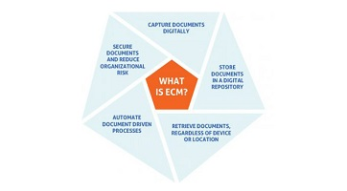

1. Capture documents digitally
Managing an organization’s content begins with the capture and importing of information into a secure digital repository. This can be any kind of document that is created, captured, stored, shared or archived, including:
- Invoices from vendors.
- Resumes from job applicants.
- Contracts.
- Correspondence.
- Research reports.
A few methods of capturing these documents include:
- Using electronic forms to make documents digital from the point of creation.
- Scanning paper documents to be filed in a digital repository.
- Managing natively digital content, including Microsoft Office documents, PDFs, photos and video files.
- Automatically filing and categorizing documents from servers, shared devices and network drives.
Traditional methods of capturing documents require a great deal of effort and expense. Capturing documents in a digital repository eliminates many of the obstacles created by paper: labor-intensive duplication, slow distribution, misplaced originals and the inconvenience of retrieving files from offsite storage.

2. Store documents in a digital repository
With robust ECM systems, organizations can easily store any business-critical document in a digital repository, allowing users to:
- Decide who can view, edit and create documents.
- Classify and search for documents based on metadata
- Organize documents within a flexible folder structure.
The benefits of enterprise content management go far beyond document storage. An ECM system also reduces the time, cost and complexity associated with managing documents that require retention schedules, throughout their life cycle, assisting in efforts to bolster regulatory compliance. In fact, a recent Nucleus Research study showed content management systems returning $6.12 for every dollar invested.

3. Retrieve documents, regardless of device or location
Once an organization’s records have been securely stored, you can:
- Find any document using full-text search.
- Identify specific words or phrases within document text, metadata, annotations and entry names.
- Use preset search options to search by document creation date, the names of users who checked out documents and other metadata.
Enterprise content management software helps eliminate time spent searching for information, enabling employees to answer information requests from clients, citizens and auditors immediately. More than that, staff have instant access to the information required to make better decisions about issues that can your organization’s bottom line.

4. Automate document-driven processes
Automation helps organizations eliminate manual tasks — such as photocopying or even drag-and-dropping digital documents — to achieve greater results with fewer resources. Some ECM systems have digital automation features that can:
- Automatically route documents to the right people at the right time.
- Alert staff members when documents require their attention.
- Recognize errors before they cause delays or make staff redo work.
Every day, businesses need purchase orders signed, records archived and employee vacation requests approved or denied. Automation moves these critical documents through the necessary steps of review and approval, in the order specified. The end result is processes that are more cost-efficient, streamlined and error-free.

5. Secure documents and reduce organizational risk
With strengthening compliance restrictions in a wide range of industries, organizations are increasingly using ECM systems to optimize records management practices and protect against risk. An enterprise content management system must provide customizable security settings to allow organizations to protect information from unauthorized access or modification. These settings should allow you to:
- Restrict access to folders, documents, fields, annotations and other granular document properties as needed.
- Monitor system login and logout, document creation and destruction, password changes and more.
- Protect sensitive metadata by controlling information access down to individual folders, templates and fields.
Leading ECM solutions enable line of business departments to manage user access independently — which means sensitive HR information stays within the HR department, while private financial information stays within the finance department, even if the information is stored in the same repository.
Most ECM platforms include a few of these 5 key elements, but category leaders — like Laserfiche — provide a complete ECM solution, helping your organization dramatically improve business processes. Schedule a demo to learn more.

What are some use cases for ECM?
An ECM can assist your organization in a variety of ways. Below are a few examples:
- Accounts payable: Capture information from invoices and purchaser orders (POs), automate invoice matching and flag mismatches between invoices and POs.
- Customer and client services: Provide secure, anytime access to documents customers and clients need with online portals hosting digital documents.
- Remote and off-site work: Give thoseworking from home or in the field the tools, content and services they need to do their jobs effectively.
- Staffing and recruiting: Streamline approvals, paperwork, and everything else involved in bringing in new talent to your organization.
- Information governance: Bolster your efforts to keep information secure and in compliance with a set of powerful records management tools.
As you can see, an ECM can help streamline a wide variety of processes. Some of the more robust ECM systems, including Laserfiche, offer marketplaces for process templates you can use to jumpstart digital transformation initiatives. To learn more about the Laserfiche Solution Marketplace, watch the video below:

What is blogging?
Blogging deals with the regular sharing of information in the form of blogs on the internet. Understanding the blog concept is essential to get an insight into blogging.

What is a blog?
A “blog” is an updated version of the old term “weblog,” used to describe websites that maintain an ongoing chronicle of information. A blog features diary-type commentary and links to articles on other websites, usually presented as a list of entries in reverse chronological order. Blogs range from personal to political and can focus on one narrow subject or a whole range of subjects. A blog is just a space
on the Web that you can create to record and express your opinions, express experiences, and interests. If you spend much time browsing the Web, you've probably read a blog post before, even if you didn't realize it at the time. Some of the most-read blogs are a bit like online magazines because they're written by a team of people who are paid to update the blog with new posts several times a day.
However, a majority of blogs are written by one person. As a result, the average blog is fairly personal, reflecting the interests and personality of the person who writes it.
The people who write blogs are called bloggers. From what you hear on the news, you might think bloggers are all a certain type of people—young, politically inclined, and tech-savvy. Or maybe you've heard about bloggers who've written about amazing experiences or ambitious projects, then turned their blogs into bestselling books. While some bloggers do fit these descriptions, a majority of bloggers don't. In fact, there's no "average" blogger—blogs are written by people of all ages and backgrounds and from all walks of life.

